Muhammad 23F-0577
Muhammad Mursaleen 23F-0659
BSCS-7D
Deep Learning for Perceptron
Assignment 1
GitHub Repo Link:
2. Part 1: Backpropagation From Scratch (15 marks)
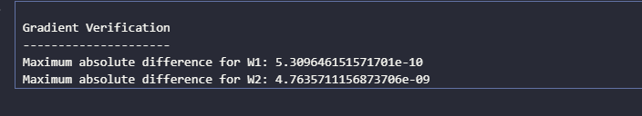
Here w1 is weight of first hidden layer and w2 is weight of second hidden layer what actually the difference is. The difference is between our calculated gradient and torch model calculated gradient this difference tells that our model is correctly calculated as difference is very much small.
Part 2: Baseline Model and Activation Study
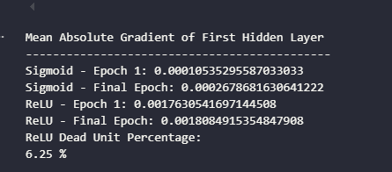
Vanishing Gradient Means Small weight to change gradient
For sigmoid: As we can see the sigmoid gradient is very small so it gives use information that the sigmoid gradient is showing vanishing gradient.
For RelU : As Relu shows that the gradient for Relu is not that much small as compare to Sigmoid so it means it is less vanishing gradient.
6.25% represent that these neurons are always zero dead not giving contribution in output.
Part 3: Loss Functions
Yes, Cross-Entropy converges faster compared to MSE because MSE uses the square of the error difference, while Cross-Entropy uses logarithmic calculation based on the predicted probability.
When Cross-Entropy gets a wrong prediction, it provides a stronger learning signal, so the weights are updated more effectively. MSE can produce smaller gradients in classification, which can make learning slower.

Part 4: Optimiser Comparison
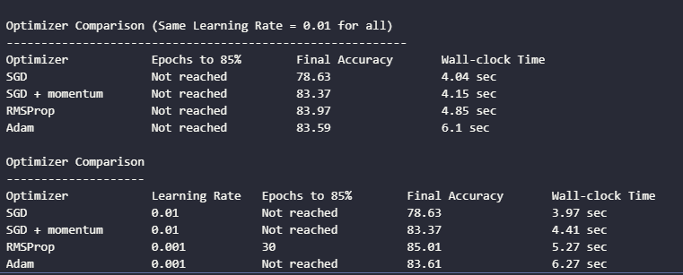
As we can see from the table above, I will choose RMSProp because it achieved the highest final accuracy of 85.01% and was the only optimizer that reached 85% accuracy in 30 epochs. Although it took slightly more time than SGD and SGD with momentum, its higher accuracy and faster convergence make it the best choice.

Part 5: Forcing Overfitting
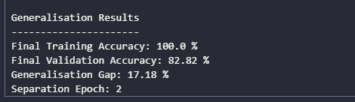
As we can see from the results above, this model has high variance, not high bias. The training accuracy reaches 100%, while the validation accuracy is only 82.82%, giving a generalization gap of 17.18%, which shows that the model performs very well on training data but less well on unseen data. Which shows high variance.
Part 6: Regularization Study
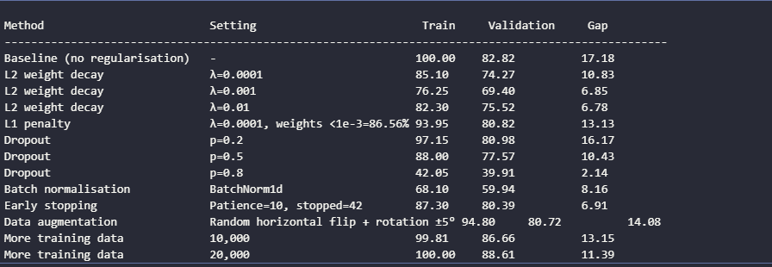
As we can see from the results above, L2 with lamda=0.01 gave the largest reduction in the generalisation gap while keeping a relatively small loss in training accuracy. The gap decreased from 17.18% to 6.78%, while training accuracy decreased from 100% to 82.30%. Early stopping also performed well, reducing the gap to 6.91% with training accuracy of 87.30%. Therefore, L2 with lamda=0.01 is the best choice because it gives the smallest gap (6.78%) while maintaining reasonable training accuracy.
Part 7: Hyperparameter Tuning with k-Fold Cross-Validation

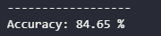
As we can see from the results above, the tuned model improved the accuracy from 83.59% in the Part 2 baseline to 84.65%. This gives an improvement of 1.06 percentage points, showing that the tuned model performed slightly better than the baseline model.

